
TECHNOLOGICAL UNIVERSITY DUBLIN
The Dining Philosophers Problem Proposal
by
Dahir Mussa , Brian Mahar, Patricia Mc Keon, Robert
Preston
Bacheior of Science in Computing
in the
School of Computing
Department of Informatics and Engineering
February 2021
TECHNOLOGICAL UNIVERSITY DUBLIN

Abstract
School of Computing
Department of Informatics and Engineering
Bacheior of Science in Computing
by Dahir Mussa , Brian Mahar, Patricia Mc Keon, Robert Preston
This project proposal describes the Dining Philosophers Problem, the solution that we are going to be studying. the proposal will includes the solution chosen,the background of the problem , aims, objectives, Project Gantt Chart.

Declaration of Authorship
“I am aware of the University policy on plagiarism in assignments and examinations (3AS08). I understand that plagiarism, collusion, and copying are grave and serious offences in the University and I will accept the penalties that could be imposed if I engage in any such activity. This assignment, or any part of it, has not been previously submitted by me or any other person for assessment on this or any other course of study. I declare that this material, which I now submit for assessment, is entirely of my own work and has not been taken from the work of others, save and to the extent that such work has been cited and acknowledged within the text of my work.”
Contents
Abstract i
Declaration of Authorship ii
List of Figures iv

- Introduction 1
  - The Dining Philosophers Problem . . . . . . . . . . . . . . . . . . . . . . . .. . . . . . . . . . . . . . . . . . . . . . . . 1
  - There are three different categories of solutions to this problem . . . . . . . . . . . . . . . . . 1
  - The solution chosen . . . . . . . . . . . . . . . . . . . . . . . . . . . . . . . . . . . . . . . . . . . . . . . . . . . . . .. . . 2
  - Compiling and running the program . . . . . . . . . . . . . . . . . . . . . . . . . . . . . . . . . . . . . . . . . . . . . 3
- Aims and Objectives 4
  - Aims . . . . . . . . . . . . . . . . . . . . . . . . . . . . . . . . . . . . . . . . . . . . . . . . . . . . . . . . . . . . . . . . . . . . . . . . . . . . 4
  - Objectives . . . . . . . . . . . . . . . . . . . . . . . . . . . . . . . . . . . . . . . . . . . . . . . . . . . . . . . . . . . . . . . . . . . . . . . 4
- Scope 5
  - Research Questions . . . . . . . . . . . . . . . . . . . . . . . . . . . . . . . . . . . . . . . . . . . . . . . . . . . . . . . . . . . . . 5
  - Tasks to Determine Success . . . . . . . . . . . . . . . . . . . . . . . . . . . . . . . . . . . . . . . . . . . . . . . . . . . . . 5
- Conclusions 6
A Project Gantt Chart 8

List of Figures
1.1 Basic Concept.PNG . . . . . . . . . . . . . . . . . . . . . . . . . . . . . . . . . . . . . …. . . . . . . . . . . . . . . . 2
A.1 ProjectGanttChart.JPG. . . . . . . . . . . . . . . . . . . . . . . . . . . . . . . . . . . . . …. . . . . . . . . . 8
Chapter 1
Introduction
The aim of this project is to study a solution in the Dining Philosophers Problem, we will be using tools such as thread Mentor visualisation tool to carry out this project.
Thread Mentor is a multi-platform tool designed to make it easy to teach and learn multithreaded programming for students. A thread is the unit of instruction in a computer process. A Thread can be single or multi-threaded [1].

1.1 The Dining Philosophers Problem
The dining Philosopher Problem is where you have five philosophers that spend their lives eating and thinking. On a circular table you have a large bowl of spaghetti in the middle of the table. There are only five chopsticks on the table one to the left of each philosopher. They each take it in turn to eat and think [2].
Each philosopher will pick up two chopsticks that are closer to them, e.g., right and the left chopsticks, if the chopsticks are available then he starts to eat until he is finished.
When he finish eating, he puts down both chopsticks and he starts to think [2].

1.2 There are three different categories of solutions to this problem
- Mutual Exclusion Locks
- Semaphores
- Monitors
1

List of Figures 2

Mutual Exclusion Locks ensure exclusive access to the data shared between threads [3]. In Semaphore are two object which are two Methods -Wait (), Signal ()[4]. Monitors have four stages as you can see from the image below. First, we have the initialization stage, then private data stage, the monitor procedure stage and the entry queue stage[5].
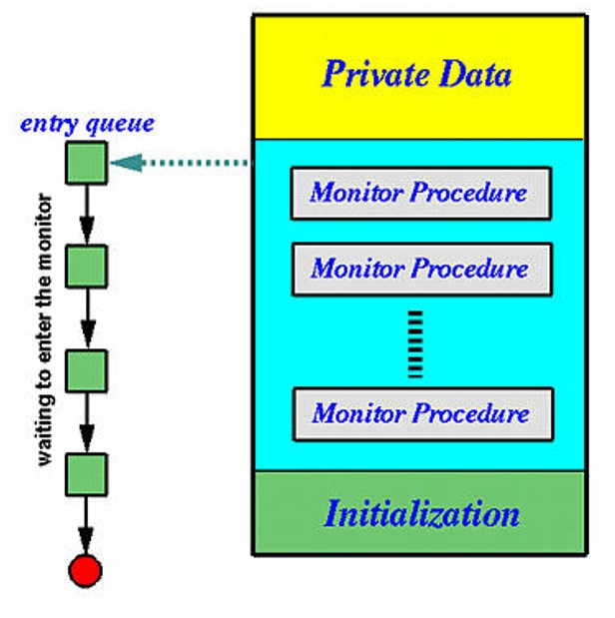
Figure 1.1: Basic Concept

1.3 The solution chosen
We have chosen the Four Chairs solution. An approach in which the fifth philosopher will be obstructed after four have already sat down. Each of them takes in turns to eat, think, and wait [6].
Allowing only four philosophers to sit at the table, if all the four philosophers pick up four chopsticks, there will be one chopstick left at the table. so, one of the philosophers can start to eat, and eventually, two chopsticks will be obtainable. We need to initialize the semaphore to four and before any philosophers pick up their chopsticks, they must first wait for the semaphore, when philosophers finish eating, they signal the semaphore to release their chair [6].

1.4 Compiling and running the program
Instructions for compiling and running the Four Chair Solution Program.
- We have a program with three files:
Philosopher-4chairs.h
Philosopher-4chairs.cpp
Philosopher-4chairs-main.cpp
- Edit the make file from Producer Consumer to reflect the name of the files from the Four Chair Program.
- Run “make”
- ./4chairs //Runs the executable program
Chapter 2
Aims and Objectives

2.1 Aims
- To study the dining philosophers and understand how the threads are made which takes in turns to access resources and how the threads work.
- To study and understand the coded solution on the ThreadMentor website.
- To show the result of running programs using the ThreadMentor visualisation tool

2.2 Objectives
- Using the ThreadMentor software.
- Break the program down and explain what is happening at the different stages.
- Research other examples to the problem.
Chapter 3
Scope

3.1 Research Questions
- What is Dining Philosophers Problem ?
- How can we prevent the deadlock from happening?
- How does deadlock occur?

3.2 Tasks to Determine Success
Compile the coded solution using the Thread Mentor visualisation tool. Study and understand about the chosen solution/code.

Chapter 4
Conclusions
we have done our research and we have chosen the Four chairs solution. the project is going in the right direction, we are enjoying it but there is a lot of work that needs to be done. The project is due to be delivered at the end of this semester.
Bibliography

[1]. Citeseerx.ist.psu.edu. 2021. [online] Available at :<https://citeseerx.ist.psu.edu/viewdoc/download?doi=10.1.1.418.6594&rep=rep1&type=pdf> [Accessed 14 February 2021].
[2]. Pages.mtu.edu. 2021. ThreadMentor: The Dining Philosophers Problem with Four Chairs. [online] Available at: <https://pages.mtu.edu/~shene/NSF-3/e-Book/SEMA/TM-example-philos-4chairs.html> [Accessed 14 February 2021].
[3]. Qnx.com. 2021. Help - QNX CAR 2 Documentation. [online] Available at: <http://www.qnx.com/developers/docs/qnxcar2/index.jsp?topic=%2Fcom.qnx.doc.neutrino.sys_arch%2Ftopic%2Fkernel_Mutexes.html> [Accessed 14 February 2021].
[4]. Pages.mtu.edu. 2021. Basic Concept. [online] Available at: <https://pages.mtu.edu/~shene/NSF-3/e-Book/SEMA/basics.html> [Accessed 14 February 2021].
[5]. Pages.mtu.edu. 2021. Basic Concept. [online] Available at: <https://pages.mtu.edu/~shene/NSF-3/e-Book/MONITOR/basics.html> [Accessed 14 February 2021].
[6]. Pages.mtu.edu. 2021. ThreadMentor: The Dining Philosophers Problem with Four Chairs. [online] Available at: <https://pages.mtu.edu/~shene/NSF-3/e-Book/SEMA/TM-example-philos-4chairs.html> [Accessed 14 February 2021].
Appendix A
Project Gantt Chart
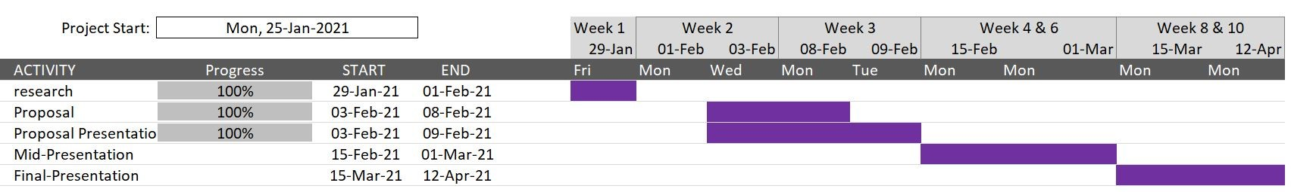
Figure A.1: Project Gantt Chart

